
Rajvardhan Zende
202501100016
SE1 S11 ESSENTIALS OF DATA SCIENCE


PRACTICE LAB ASSIGNMENT
1.1.1 CALCULATE MOMENTUM Write a programthatacceptsthemassofanobject(in kilograms) and its velocity (in meters per second), then calculatesanddisplaysthemomentumoftheobject. The momentum is calculated using the formula: p= m *v
where:
is the mass of the object (in kilograms).
is the velocity of the object (in meters per second).
Input Format:
A single floating-point number representing the mass of the object in kilograms.
A single floating-point number representing the velocity of the object in meters per second.
Output Format:
The output will display calculated momentum with appropriate units (kgm/s) (rounded up to 2 decimal places).

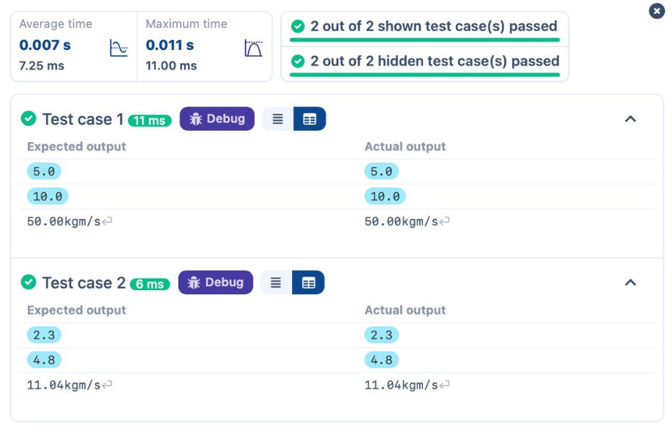
INPUT
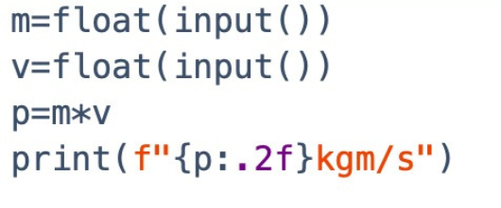
OUTPUT

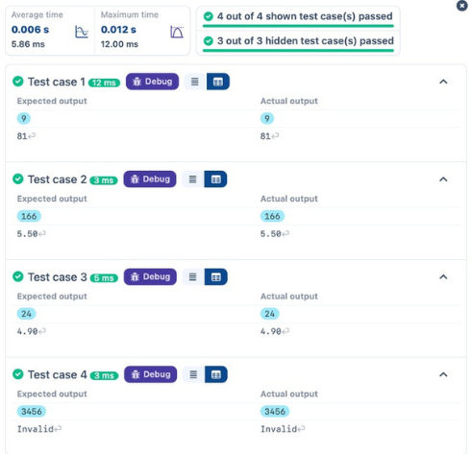
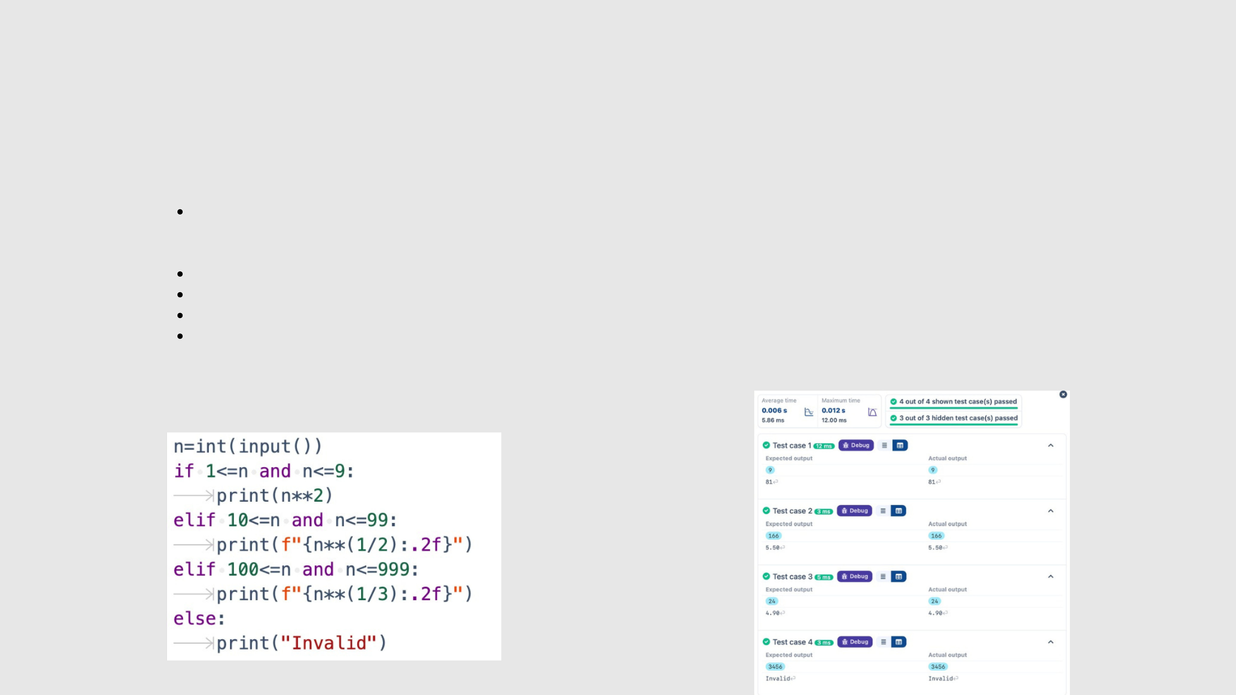
1.1.2 CONDITIONAL CALCULATION BASED ON THE NUMBER OF DIGITS
Write a Python program that accepts an integer n as input. Depending on the number of digits in n.
Constraints:
1 ≤ n ≤ 999
Input Format:
The input consists of a single integer .
Output Format:
If n is a single-digit number, print its square.
If n is a two-digit number, print its square root (rounded to two decimal places).
If n is a three-digit number, print its cube root (rounded to two decimal places).
Else print "Invalid".
INPUT OUTPUT

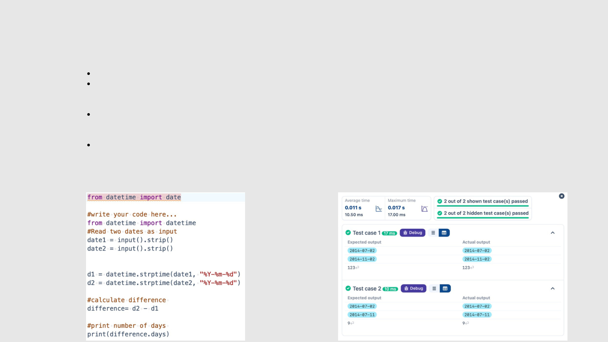
1.1.3 DAYS BETWEEN TWO DAYS
Write aPythonprogramtocalculatenumberofdaysbetweentwodates.
Input Format:
The first line contains the first date in the format : YYYY-MM-DD
The second line contains the second date in the format :YYYY-MM-DD
Output Format:
An integer representing the number of days between the given dates.
Note:
The first date should always be considered earlier than the second date.
INPUT OUTPUT

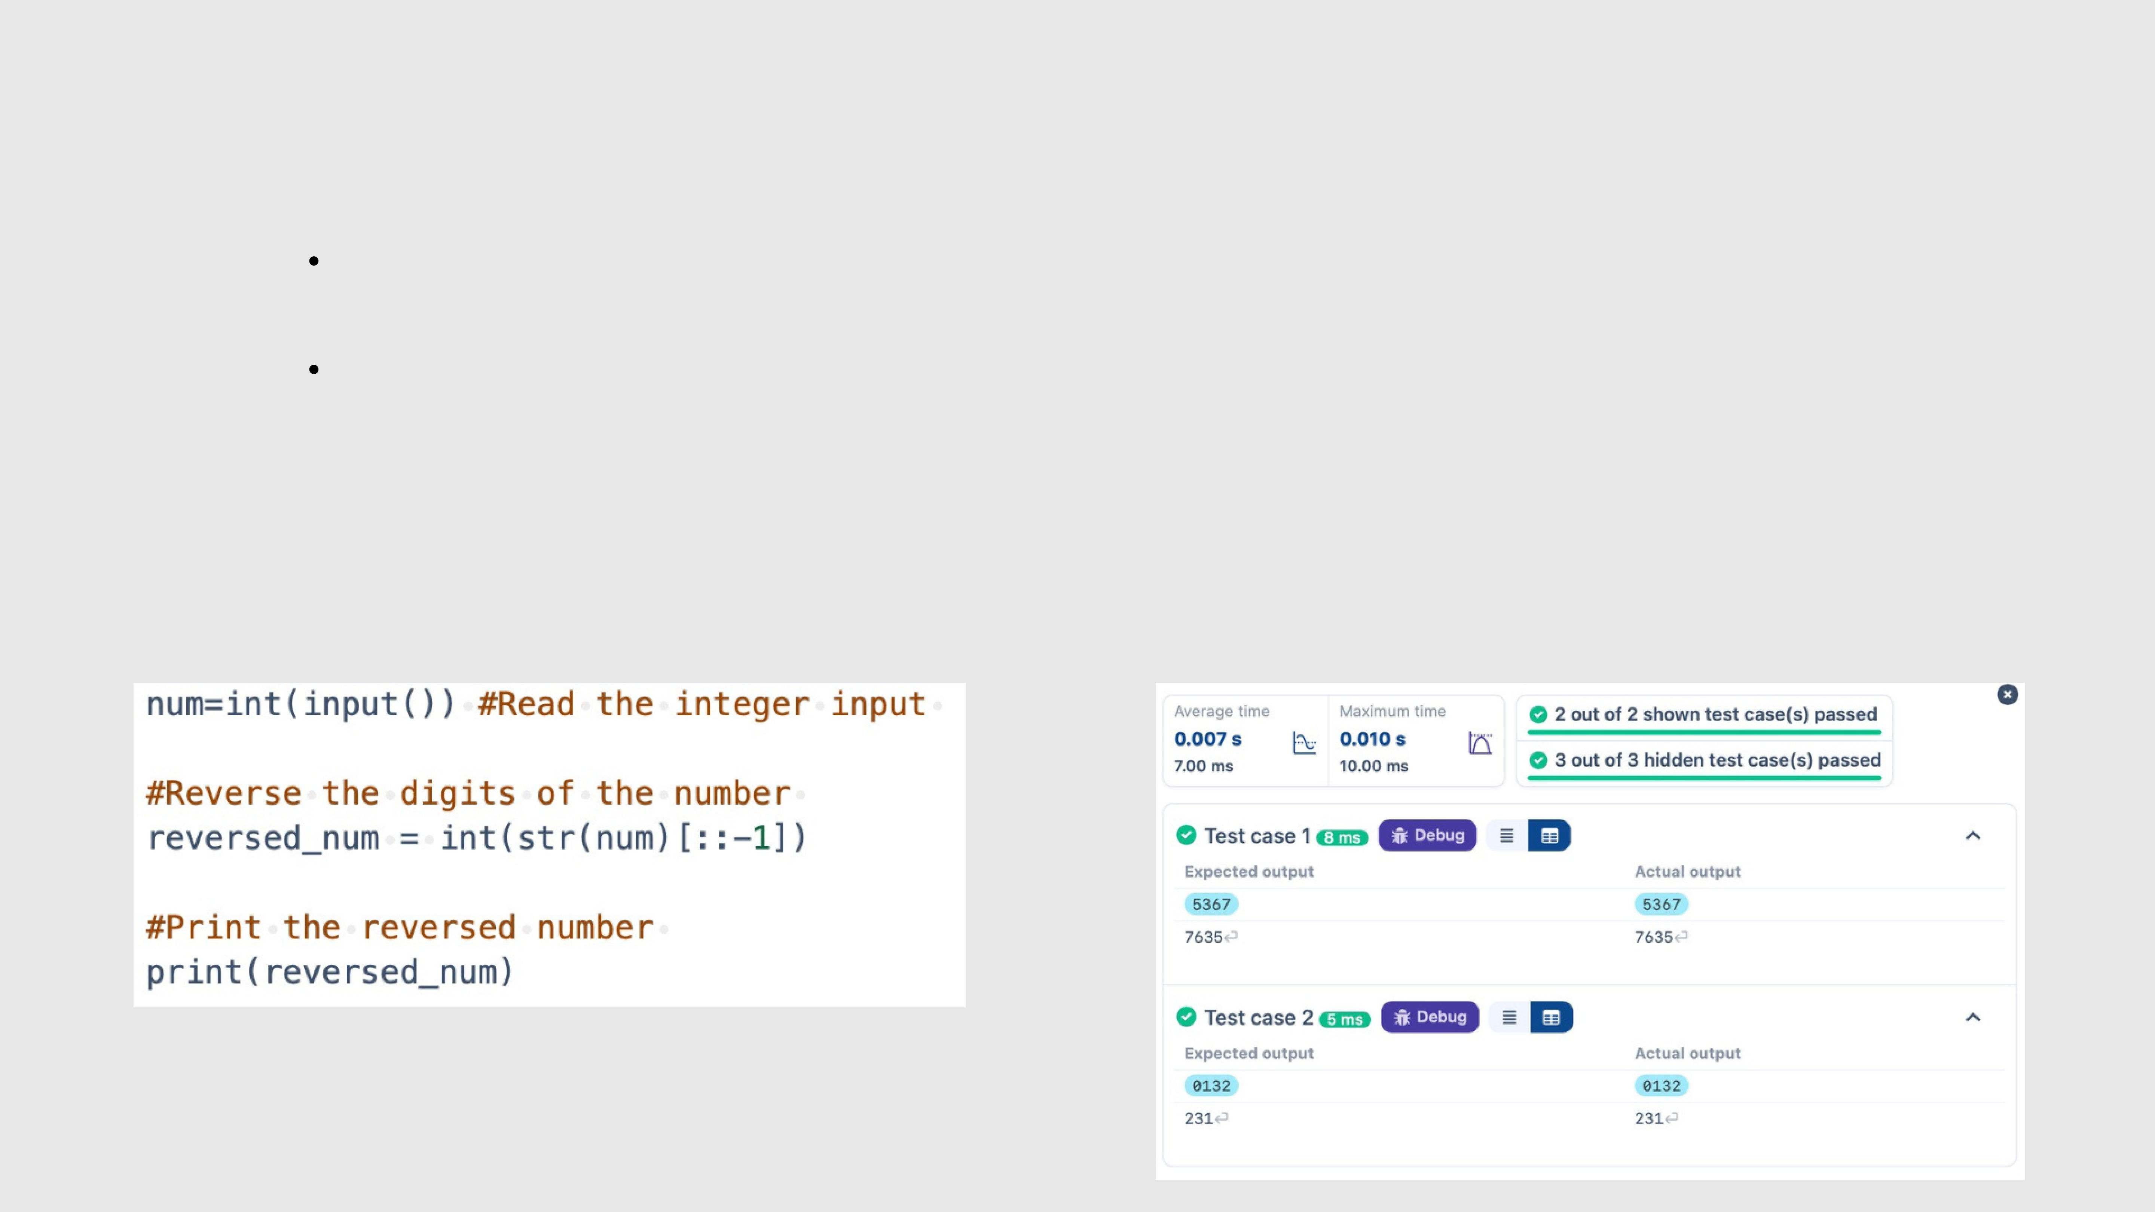
1.1.4 REVERSE A NUMBER
Write aPythonprogramtoreversethedigitsofthenumber and print the reversed number.
Input Format:
The input is a single integer.
Output Format:
The output prints a single integer, which is the reversed number.
INPUT OUTPUT

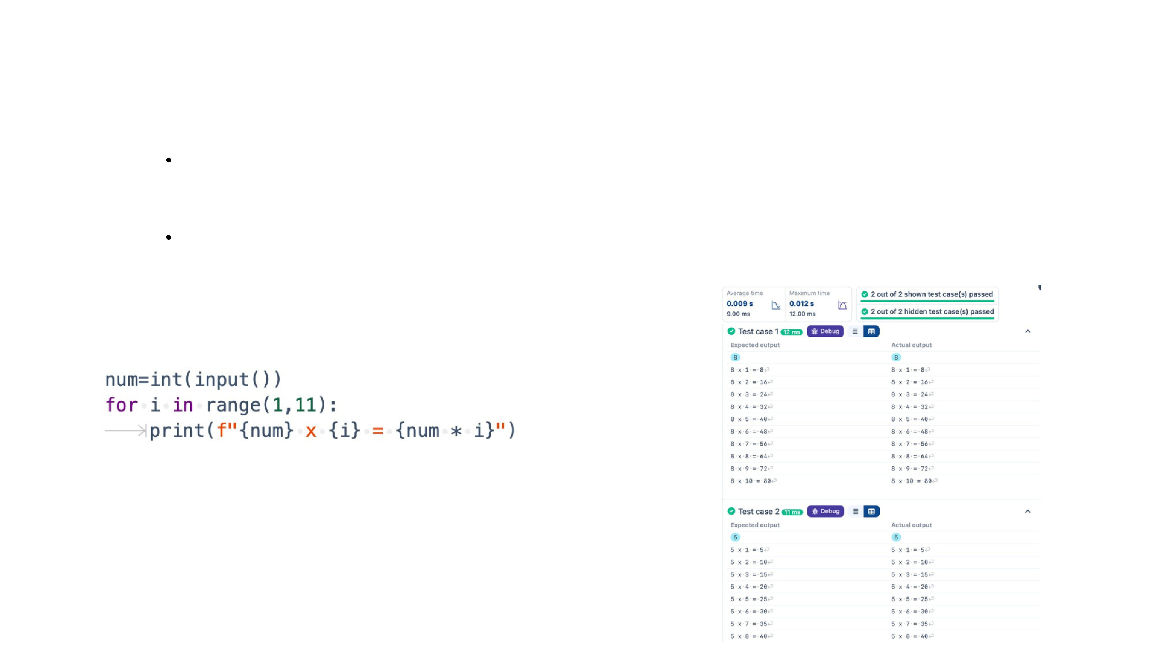
1.1.5 MULTIPLICATION TABLE WriteaPythonprogramthattakesanintegerasinputandprints the multiplication table for that integer from 1 to 10.
Input Format:
The first line of input contains an integer that represents the number for which the multiplication table is to be printed.
Output Format:
Print the multiplication table for the given number in the format:
<number> x <multiplier> = <result>
OUTPUT
INPUT

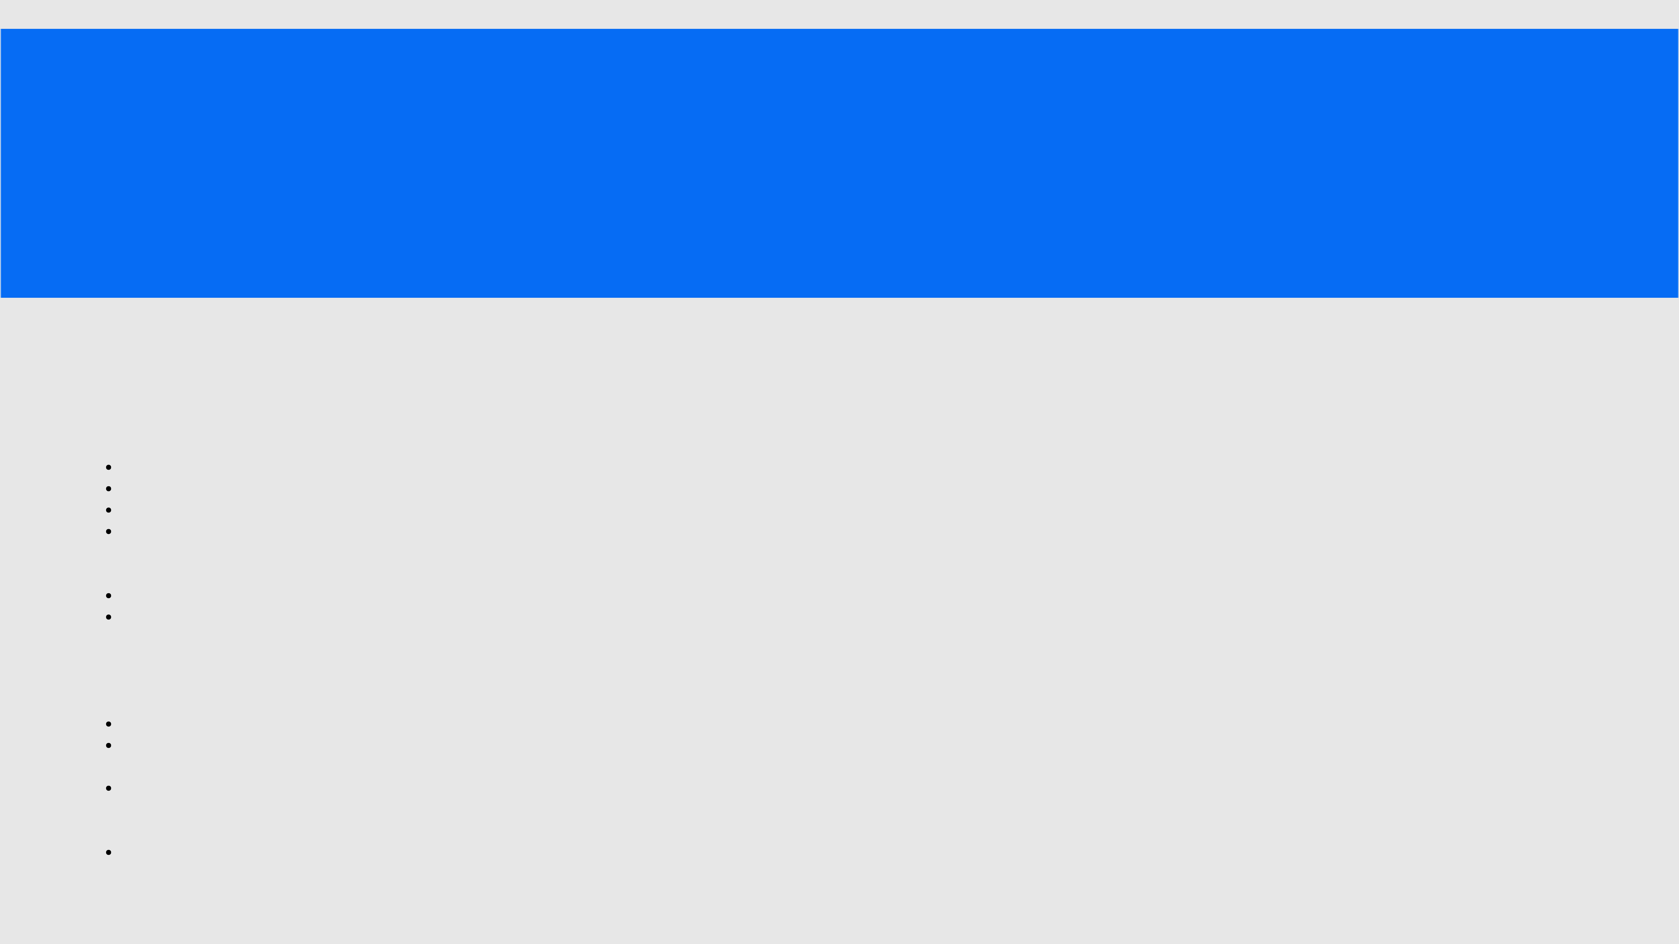
LAB ASSIGNMENT
1.2.1 PASS OR FAIL
Write aPythonprogramthatacceptsthenumber of coursesand the marks of a student in those courses.
The grade isdeterminedbased on theaggregate percentage:
If the aggregate percentage is greater than 75, thegrade is Distinction.
If the aggregate percentage is greater than or equal to 60 but less than 75, the grade is First Division. If the aggregate percentage is greater than or equal to 50 but less than 60, the grade is Second Division. If the aggregate percentage is greater than or equal to 40 but less than 50, the grade is Third Division.
Input Format:
The first input will be an integer , the number of courses.
The second input will be integers representing the marks of the student in each of the courses, separated by a space.
Output Format:
If the student passes all courses:
Print the aggregate percentage (formatted to two decimal places).
Print the grade based on the aggregate percentage.
If the student fails any course (marks < 40 in any course), print:
"Fail".
Note:
Aggregate Percentage: Average performance across all courses, calculated by summing all marks and dividing by the number of courses.

INPUT OUTPUT

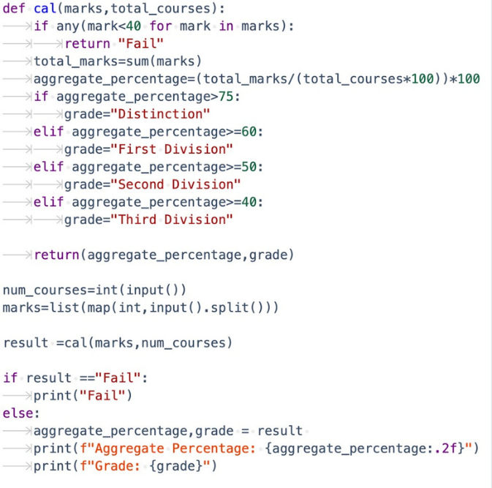

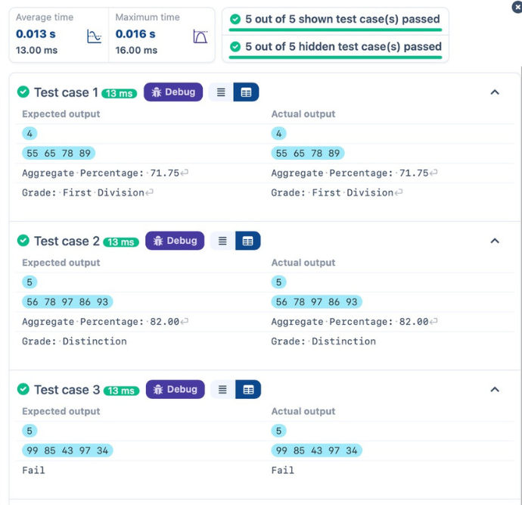

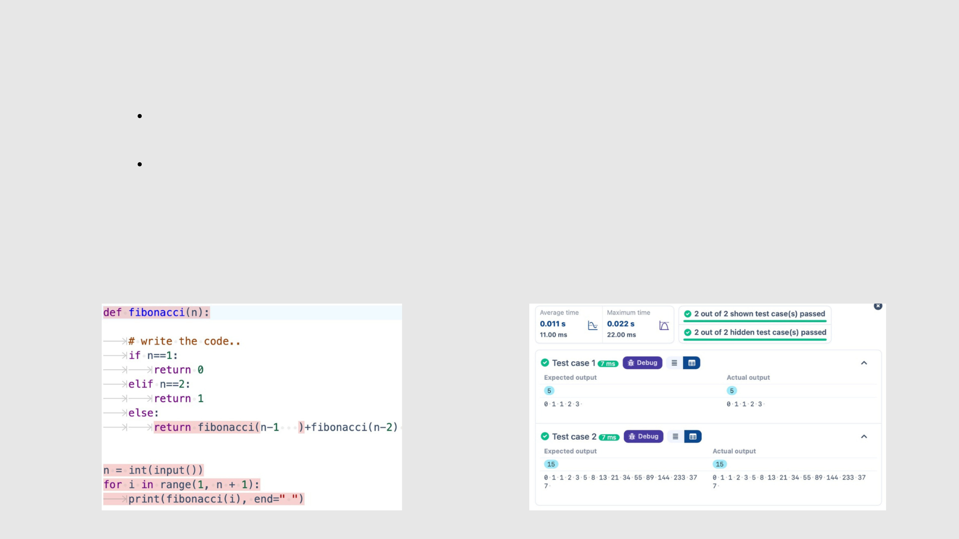
1.2.2 FIBONACCI SERIES Write aPythonprogramthatusesrecursiontoprint the first n terms of the Fibonacci series.
Input Format:
A single integer n representing the number of terms to generate.
Output Format:
A single line containing the first n terms of the Fibonacci sequence, separated by spaces.
INPUT OUTPUT

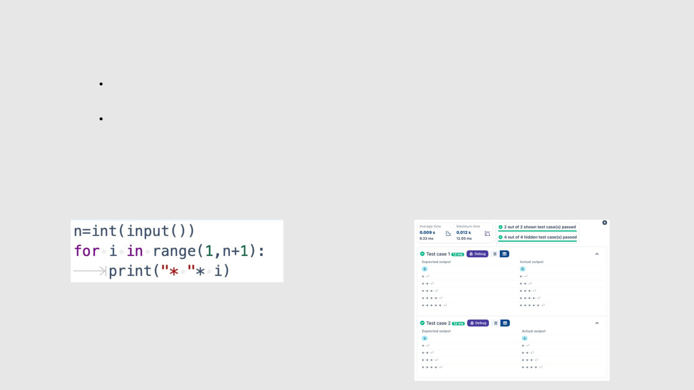
1.2.3 PATTERN-1 Write aPythonprogramtoprint a pattern of asterisks in the form of a right-angled triangle.
Input Format:
The input is an integer, representing the number of rows in the pattern.
Output Format
The output should display the pattern of asterisks (*), with each row containing an increasing number of
asterisks.
Note: Refer to the displayed test cases for the sample pattern.
INPUT OUTPUT

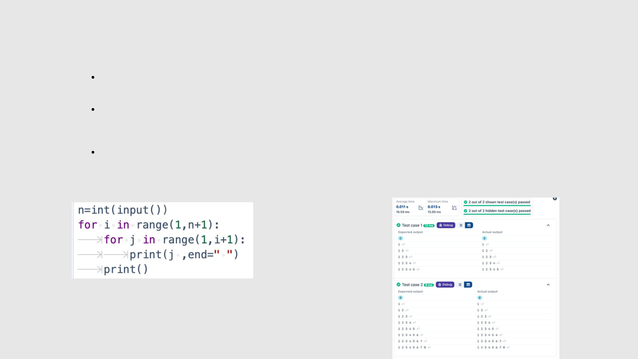
1.2.4 PATTERN-2 Write aPythonprogramtoprint a right-angled triangle pattern of numbers.
Input Format:
The input is an integer, representing the number of rows in the pattern.
Output Format:
The output should display the pattern of numbers separated by space, with each row containing increasing
numbers starting from 1 up to the row number.
Note:
Refer to the displayed test cases for the sample pattern.
INPUT OUTPUT

